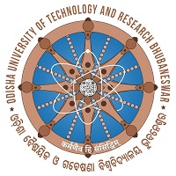 | ଓଡ଼ିଶା ବୈଷୟିକ ଓ ଗବେଷଣା ବିଶ୍ବବିଦ୍ୟାଳୟ  Odisha University of Technology and Research  Ghatikia, Bhubaneswar-751029  www.outr.ac.in

Ref No. 1112 (misc.) /OUTR Date:- 03 / 10 /2023

NOTICE FOR
MERIT SCHOLARSHIP FOR CHILDREN OF EX-SERVICEMEN/WIDOWS

The Govt. of Odisha have introduced a Merit Scholarship for Children of Ex-Servicemen/Widows as notified vide letter no. SDTE-PDE-II-Poly-0037-2023 7169/SDTE dated 29.9.2023 of the SD&TE Department, Govt. of Odisha.
The Home Department, Govt. of Odisha vide their letter no. 37439/Polt dated 14.9.2023 have notified the guidelines on eligibility criteria, amount scholarship, procedure of submission of application etc. which is enclosed herewith.
All the eligible students as above are hereby advised to apply for this Merit scholarship.
Students are required to submit the Application in the prescribed format (available in Zilla Sainik Boards/Rajya Sainik Board) with bonafide studentship certificate (available at the University) duly completed in all respect with their respective Zilla Sainik Boards latest by November 30 each year.
The last date of submission of application is November 30, 2023.

Sd/-
Dean, Academic Affairs

